**wPortal: IIS 7 Web Server Installation**

Version 4.7.0.0

**Summary**:

wPortal installation process with IIS7

**Contents**

1 Document Information 4

1.1 History 4

1.2 Mailing List 4

1.3 Related Documents 4

2 Introduction 6

2.1 Global architecture 6

2.2 Installation setup 6

2.3 Prerequisites 6

2.4 Terminology 6

3 WebServer Installation 7

3.1 Install IIS 7

3.2 Install wPortalNinja 7

3.3 WSM eWED 32 bit Installation 7

3.4 Configure IIS 8

3.5 GSP Configuration 10

4 Test WebServer 12

4.1 Purpose 12

4.2 Procedure 12

4.3 Expected result 13

You should have the following screen, maybe with different values. 13

4.4 Known issues : 13

5 AppServer Installation 14

5.1 Install Wyde RPC Server 32 bit 14

5.2 Install WyseMan Server 32 bit 14

5.3 Script creation 14

5.4 WyseMan Configuration 14

5.5 Test WySeMan 15

5.5.1 Test purpose 15

5.5.2 Test procedure 15

5.5.3 Expected result 16

5.5.4 Known issues 16

5.6 Install WyseMan as a service (optional) 16

6 wPortal framework Installation 20

6.1 wPortal Bundles 20

6.2 Test wPortal 20

6.2.1 Test purpose 20

6.2.2 Test procedure 20

6.2.3 Expected result 20

6.2.4 Known issues 20

7 Install wPortal with SQL Server or Oracle 24

8 End of document 25

1. Document Information
   1. History

|  |  |  |  |
| --- | --- | --- | --- |
| **Version** | **Modifications Description** | **Author** | **Date** |
| 0.1 | Création du document | jproger | 07/06/2010 |
| 1.0 | Issues report | jproger | 01/07/2010 |
| 1.1 | Some few corrections | jproger | 07/07/2010 |
| 4.4.0 | Test WySeMan, Tip section for UrlMapping, a few corrections about 4.4 | jproger | 03/02/2011 |
| 4.4.1 | A few corrections, added “missing gsp file” error resolution | Jproger | 07/02/2011 |
| 4.4.2 | A few corrections | Cbittel | 08/02/2011 |
| 4.4.3 | A few informations about install with Oracle or SQL Server | Jproger | 09/02/2011 |
| 4.4.4 | More precisions about wPortalConfig.xml parameters description and about WySeMan install as a service. | Jproger | 11/02/2011 |
| 4.6.0 | New release | Jproger | 28/02/2012 |
|  |  |  |  |

* 1. Mailing List

|  |  |  |
| --- | --- | --- |
| **Name** | **Company** | **Email** |
| Jean-Philippe Roger | WYDE | [jproger@wyde.com](mailto:jproger@wyde.com) |
| Sébastien André | WYDE | [sandre@wyde.com](mailto:sandre@wyde.com) |
|  |  |  |

* 1. Related Documents

|  |  |
| --- | --- |
| **Name** | **Description** |
|  |  |
|  |  |
|  |  |

1. Introduction
   1. Global architecture

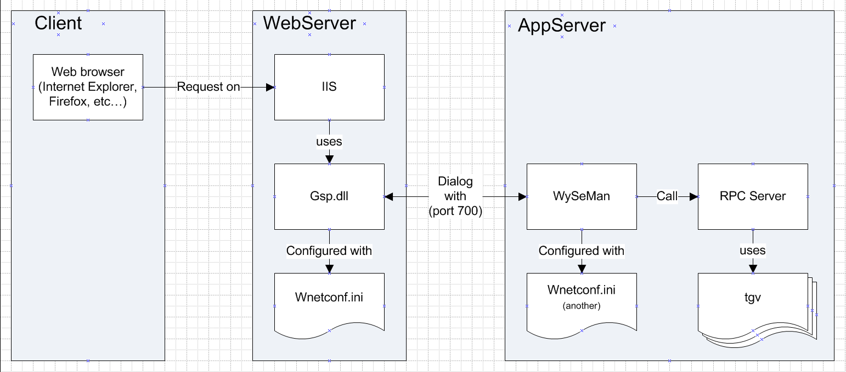

* 1. Installation setup

|  |  |
| --- | --- |
| Description | Source |
| wPortalNinja | Wyde Product\Wynsure\Wynsure Portal 4.7\4.7.x.x\wwwroot\inetpub |
| WSM eWED | Wyde Product\eWam & Related Products\Installations 6.0\eWAM 6.0.x.x & Related Products\**win32**\WSM eWED 6.0.x.x |

* 1. Prerequisites
* Having IIS6 or IIS7 installed on WebServer
* Having Ewam installed on AppServer and configured with its corresponding database.
  1. Terminology
* “WebServer” or [WebServer] stands for Web Server machine name.
* “AppServer” or [AppServer] stands for Application Server machine name.
* “Client “ or [Client] stands for the Client machine name.
* WebServer, AppServer, Client can be installed on the same machine.
* (WYDE-ROOT) correspond to the location where your eWam is installed.

1. WebServer Installation

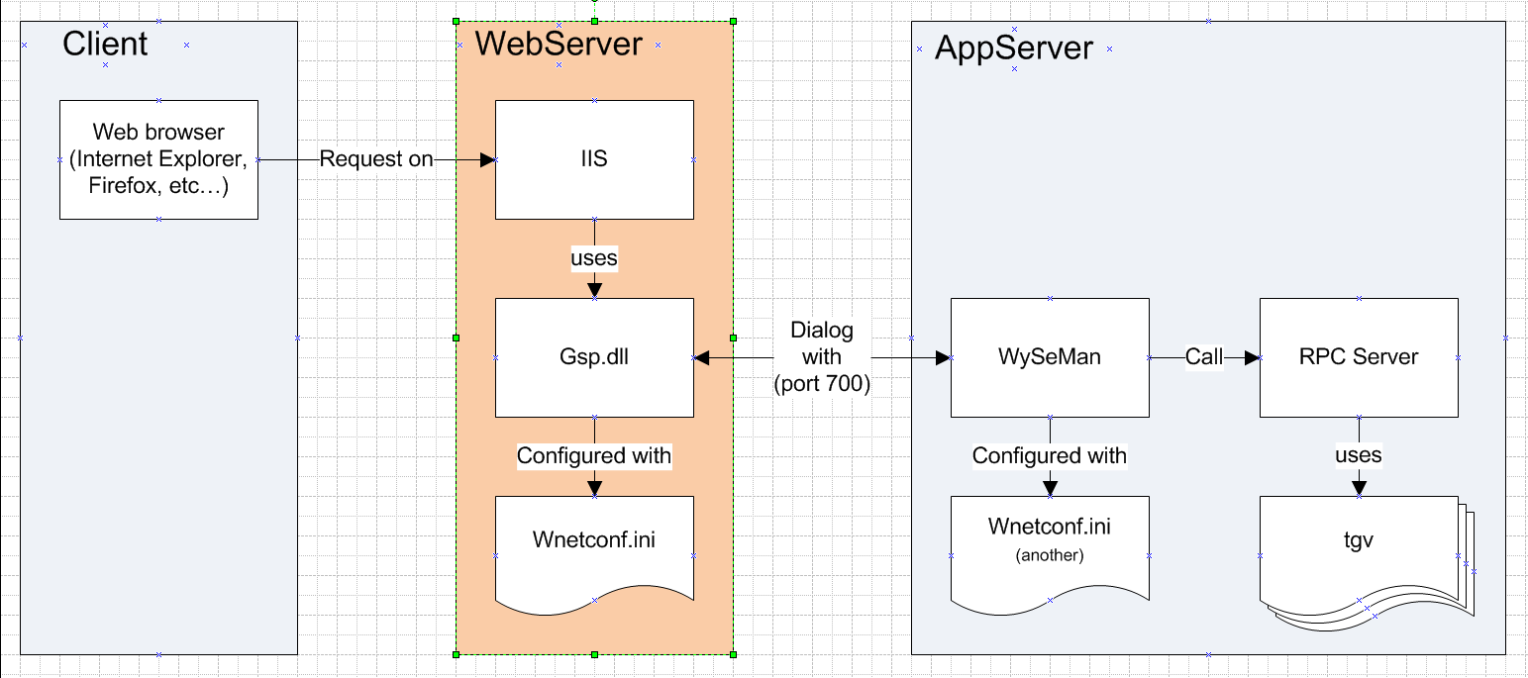

* 1. Install IIS
* For windows vista, windows 2003, windows 7
  1. Click on “Control Panel” 🡺 “Programs” 🡺 “Turn Windows features on or off”
  2. Check “Internet Information Services” (full check)
  3. Validate
* For Windows XP
  1. Click on “Control Panel” 🡺 “Programs”
  2. Click on “Add or remove Windows features” on left tab
  3. Check “Internet Information Services” (full check)
  4. validate
  5. Install wPortalNinja

Paste files in:   
C:\ Inetpub\wwwroot\

In order to have the following folder:  
c:\Inetpub\wwwroot\wPortal\css

* 1. WSM eWED 32 bit Installation

1. Launch setup
2. Install as HTTP Server in C:\Inetpub\
   * A new folder C:\Inetpub\GSP has been created.
   * The other files created in C:\Inetpub and ewedscripts folder are useless for us.
   1. Configure IIS

The virtual folder allows you to have your web site files (such as js, css, etc…) out of C:\Inetpub

1. Open IIS service manager
2. Create Virtual Directories  
   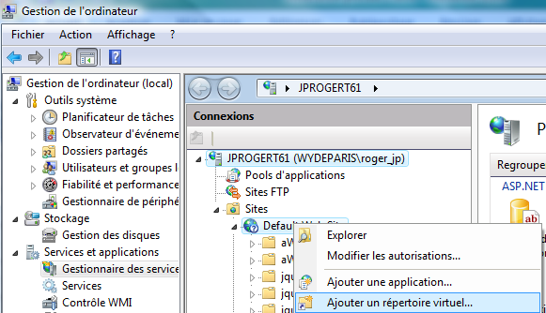
   1. Right click on “Default Web Site” 🡺 New 🡺 Virtual Folder…
   2. Alias : **liclient**
   3. Path : C:\Inetpub\wwwroot\wPortal\  
      *(the folder containing : js, css, theme… folders)*
   4. Validate
   5. Repeat from step a. with alias **ligroupadmin** and **libroker**.
3. Configure the Virtual Directories
   1. Click on Default Web Site 🡺 mapping manager  
      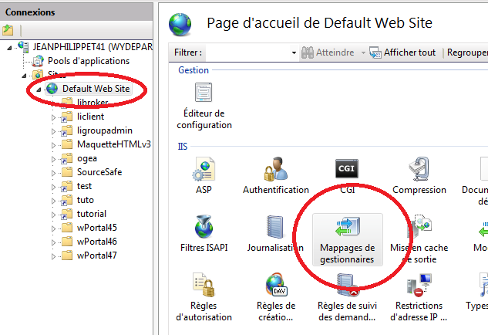  
      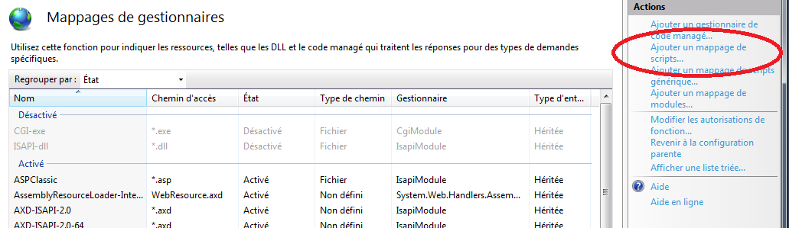  
      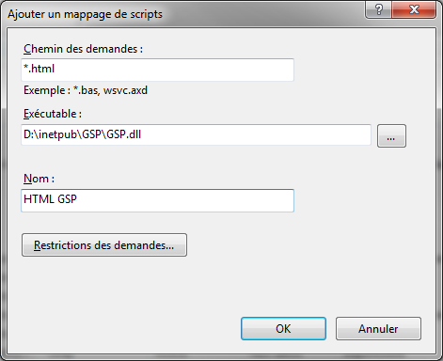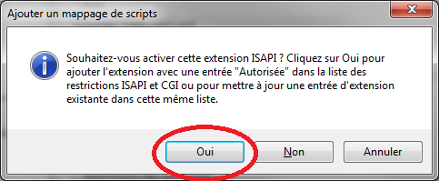

Click on “Add script map…” link on the right panel

* + - Extension : “*.html”  
      *(without quote)*
    - Executable : C:\Inetpub\GSP\GSP.dll
    - *Name : HTML GSP*
    - *Validate*
    - *Click Yes button to activate ISAPI extension*

1. Configure Default Document  
   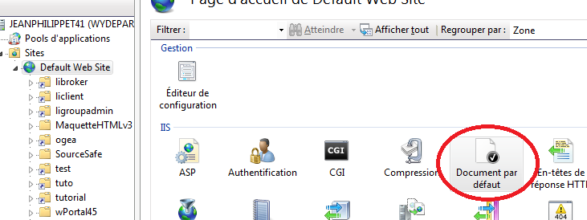
   1. Click on “Default Web Site”
   2. Click on “Default Document”
   3. Remove all document, except index.html  
      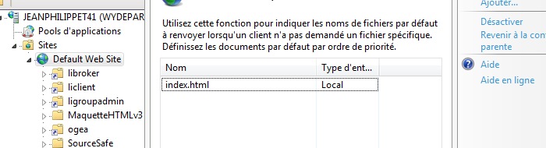
2. Restart IIS
   1. GSP Configuration
3. Open the file  
   C:\Inetpub\GSP\WNETCONF.ini
4. Locate the following service node :  
   /WydeNetWorkConfiguration/ClientConfiguration/Services/Service[Name=’GSP’]
5. Under this service node, <Host> = [AppServer]  
   *If you are installing all on your laptop, [AppServer] = localhost*
6. Under this service node, <Port> = 700
7. Clean WNETCONF.ini (optional) :
   * Locate GSP Service and remove all unnecessary service in :  
     /WydeNetWorkConfiguration/ClientConfiguration/Services
   * Remove the following unnecessary node and all its sub nodes :   
     <ServiceManager>
8. Test WebServer
   1. Purpose

Test communication and configuration between Client and WebServer

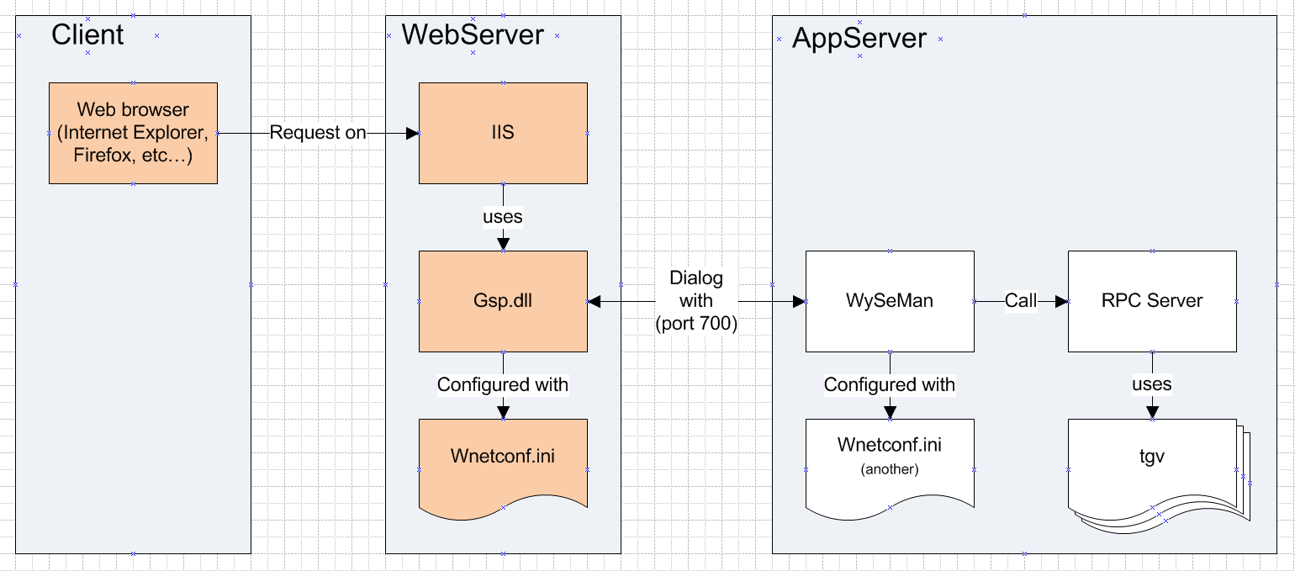

* 1. Procedure

1. You can test the WebServer configuration by typing the following URL on the client browser:   
   http://[WebServer]/ wnetconf.html
2. If this test doesn’t work, you won’t be able to go further. Refer to the following section “Know issues”.
   1. Expected result

You should have the following screen, maybe with different values.

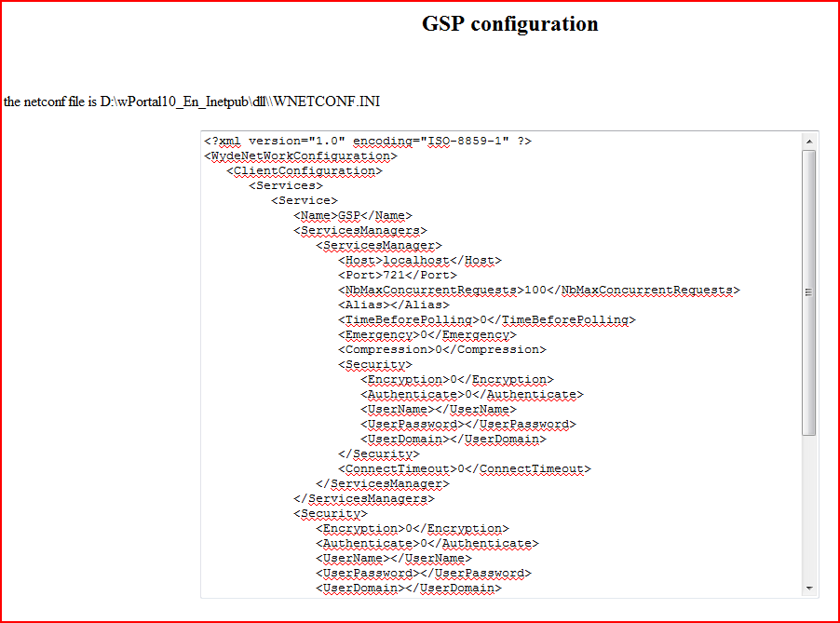

* 1. Known issues :
  + Be sure every Wyde components are installed in 32 bits.
  + The dll GSP.dll maybe not have been updated to support correctly command line http://[WebServer]/wnetconf.html, so you may have to add a new script map with *.gsp in order to type the following command line :  
    http://[WebServer]/wnetconf.gsp
  + If the result is a white page, maybe with a few characters, try to disable antivirus, and call back the URL. This problem only occurs on this particular web page.
  + If you are trying to configure GSP.dll (32bit) on a 64 bit OS :
    - For IIS 7  
      Click on your application pool and click on advanced configuration, you should find an option to authorize the application pool to launch 32 bit dll.

1. AppServer Installation

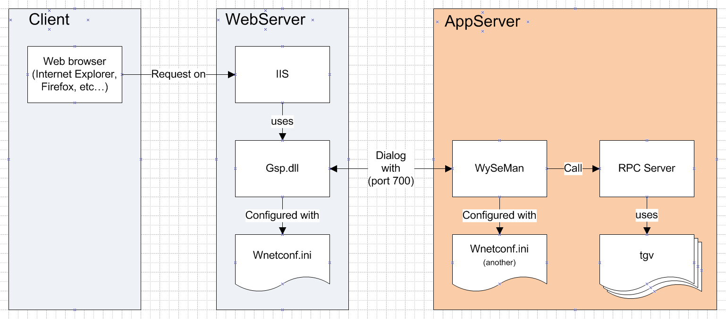

* 1. Install Wyde RPC Server 32 bit

1. Launch Setup
2. Install in (WYDE-ROOT)
   1. Install WyseMan Server 32 bit
3. Launch Setup
4. Install as WyseMan server in (WYDE-ROOT)\WSMServer
   1. Script creation
5. Create the file (WYDE-ROOT)\bin\Launch Wyseman.bat  
   *(here, WyseMan is listening for port 700, be sure this port is not already used)*

@call "eWam Set env.bat"  
@set WYDE-NETCONF=%WYDE-ROOT%\WSMServer\WNETCONF.ini

start ..\WSMServer\WySeMan.exe %* /PORT:700

1. Edit (WYDE-ROOT)\bin\eWam Set env.bat  
   🡺verify your WYDE-ROOT

@rem the next line is modified during the setup  
@set WYDE-ROOT=C:\Wynsure46  
@call "ewam set env from wyde-root.bat"

* 1. WyseMan Configuration

1. Open file :  
   (WYDE-ROOT)\WSMServer\WNETCONF.ini
2. (optional) Remove the following unnecessary node and all its sub nodes:  
   <ClientConfiguration>
3. (optional) Locate GSP Service and remove all others unnecessary service in :  
   /WydeNetWorkConfiguration/ServicesManager/Services
4. In the GSP Service, fill the node <CommandLine> with the following parameter   
   WedRPCServer.exe /ERRORMESSAGE:TRUE /DEMO:TRUE /WFAPPLINAME:WynsureSolution /RUNCONTEXTNAME:MultiLanguageRunningContext /MULTISESSION:TRUE /SERVERCLASS:GSP=aPCB_GSPServer
   * ERRORMESSAGE: TRUE or FALSE, when set to FALSE, no error will pop up to your screen, and you won’t be able to debug properly (production mode or demo mode).
   * DEMO: TRUE or FALSE, when set to TRUE, the login screen will contain a combo box for all available login, and automatically set the password.
   * WFAPPLINAME: Here, the application to launch is WynsureSolution, depending on the application you want to run.
   * RUNCONTEXTNAME: The running context is MultiLanguageRunningContext, depending on the running context you want to have.
   * MULTISESSION: always set this to TRUE for wPortal.
   * SERVERCLASS: The Server class to be used is the last child class under aWTW_GSPServer, depending on the bundles installed (here aWCBW_GSPServer).
   1. Test WySeMan
      1. Test purpose

Verify WySeMan is able to raise a process.

* + 1. Test procedure
* Launch (WYDE-ROOT)\bin\Launch Wyseman.bat on AppServer.
* Double click on WySeMan icon in systray  (close to the clock)
* Click on “start administration mode” button in WySeMan 
* Right click on Running process under GSP service  
  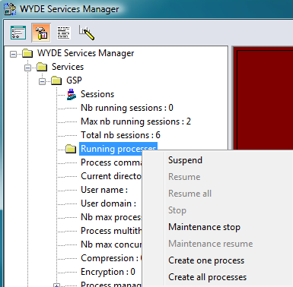
* Click on “Create one process”
  + 1. Expected result

A sub node should be created under “Running processes”

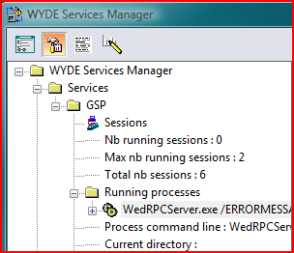

* + 1. Known issues
* **Nothing happens**
  + Problem description  
    Mixing 32 bit application and 64 bit application cannot work.
* How to solve the problem  
  Verify every application is installed in 32 bit.
* **Nothing happens**
  + Problem description  
    You are launching WySeMan from batch, and it is not able to call WedRPCServer.exe
* How to solve the problem  
  This executable should exist: (WYDE-ROOT)/dll/WedRPCServer.exe, if not verify installation of Wed RPC Server.
* **Nothing happens**
  + Problem description  
    WySeMan is installed as a service, and it is not able to call WedRPCServer.exe
  + How to solve the problem  
    Check environment variables of your system, especially your PATH, (WYDE-ROOT)/dll/ should be specified.
  1. Install WyseMan as a service (optional)

This procedure allows WySeMan to start when the computer starts, even if no user is logged in.

You should follow this procedure only if you already have installed everything, and it passed all testes of this document.

1. Configure environment variables of your account.
   * Open your environment variable panel (Right click on “Computer” 🡺 properties 🡺 advanced 🡺 environment variables)  
     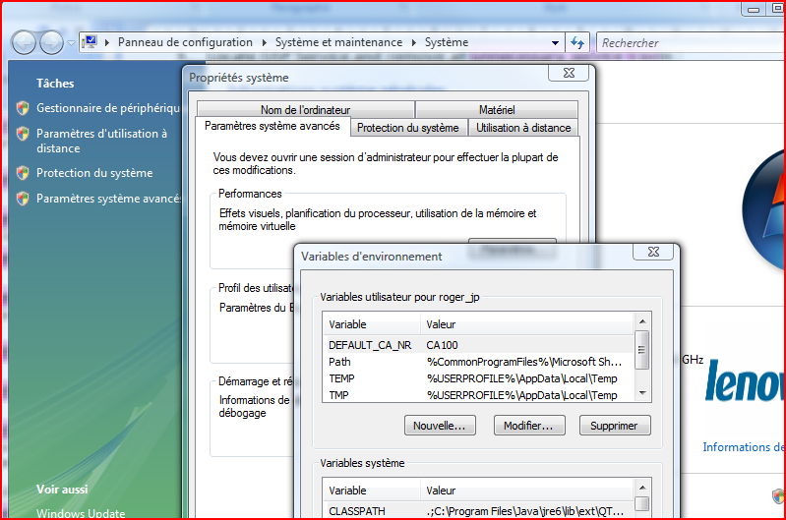
   * The following variables should be set directly in your account environment variables :  
     (eWAM Set Env From WYDE-ROOT.bat)  
     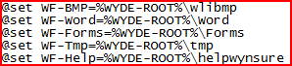  
     (eWAM Set Env.bat)  
     
   * The following variables should be added to the PATH environment variable:  
     (eWAM Set Env From WYDE-ROOT.bat)  
     
2. Create a file  
   C:\WyseMan\Install Service Wyseman.bat
3. Paste this content (here WySeMan is listening for port 700):  
   start wyseman /port:700 /installservice /NETCONF: C:\WyseMan\WNETCONF.ini
4. Close WySeMan in systray if necessary.
5. Launch C:\WyseMan\Install Service Wyseman.bat
6. Start 🡺 Run 🡺 Services.msc
7. Locate Wyseman:700
8. Start it in automatic launch.  
   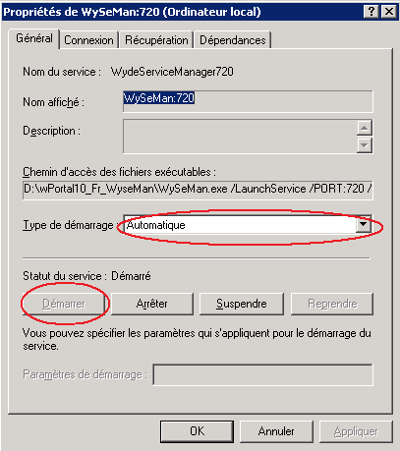
9. (Optional): You can configure WSMAdmin to be launched without any authentication.  
   You have to modify windows registry to add to the service the following parameter /AUTHENTIFIEDADMIN:FALSE  
   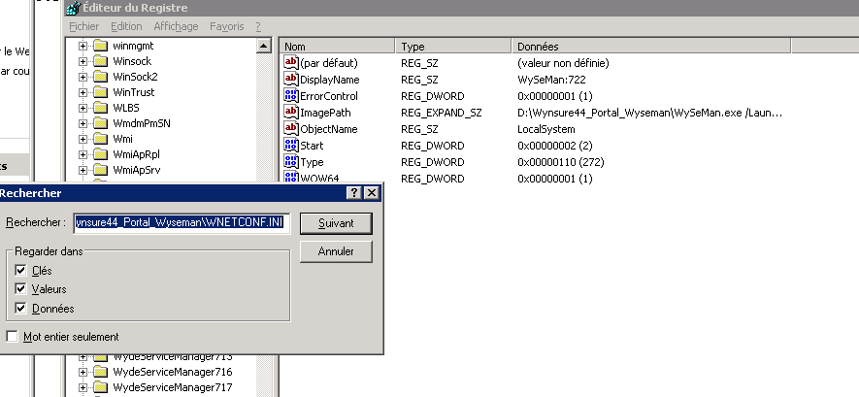  
   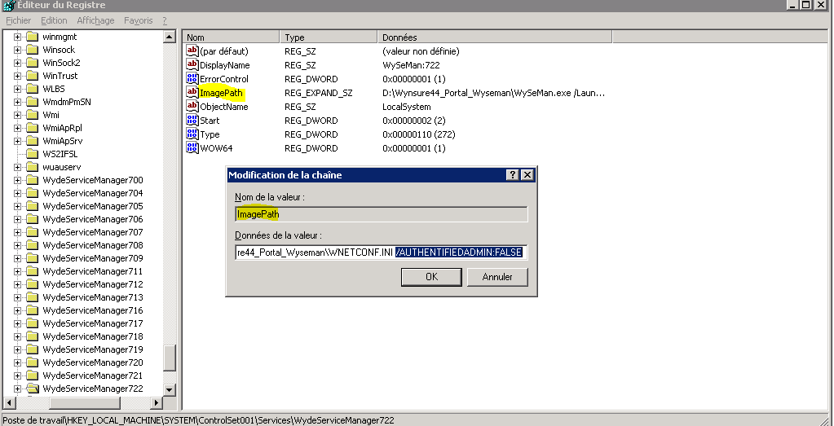
10. wPortal framework Installation
    1. wPortal Bundles

Install wPortal bundles.

* 1. Test wPortal
     1. Test purpose

Test wPortal…

* + 1. Test procedure
* Type the following URL in your browser to access to client portal :  
  <http://[WebServer]/liclient/>
* Type the following URL in your browser to access to broker portal :  
  <http://[WebServer]/libroker/>
* Type the following URL in your browser to access to group admin portal :  
  <http://[WebServer]/ligroupadmin/>
  + 1. Expected result

You should have the following result:

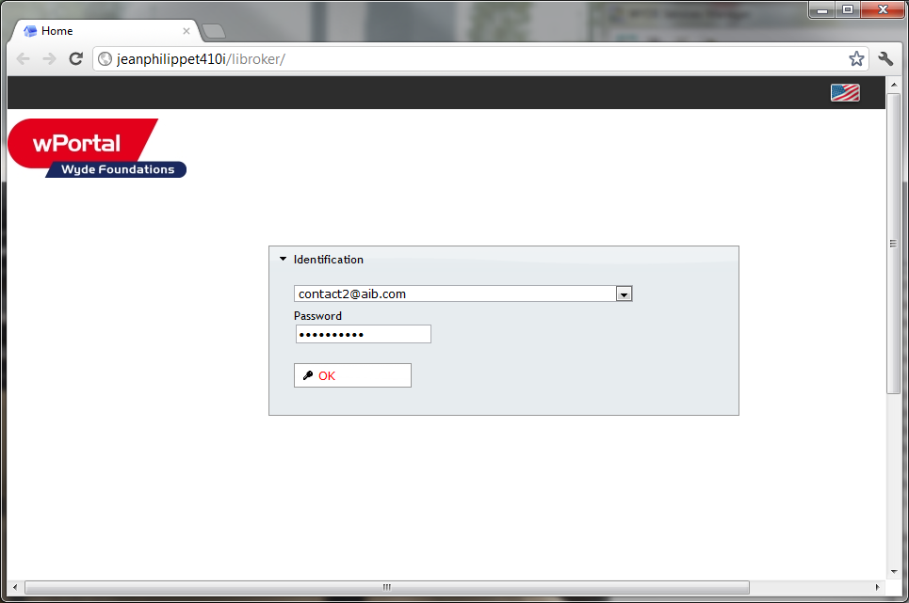

* + 1. Known issues
* **Service Unavailable  
  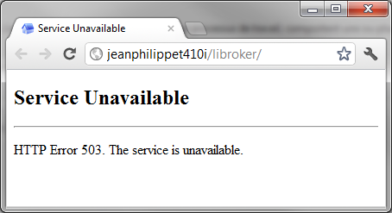**
  + Problem description  
    Your Application Pool may be stopped
  + How to solve the problem  
    Verify your application pool is started  
    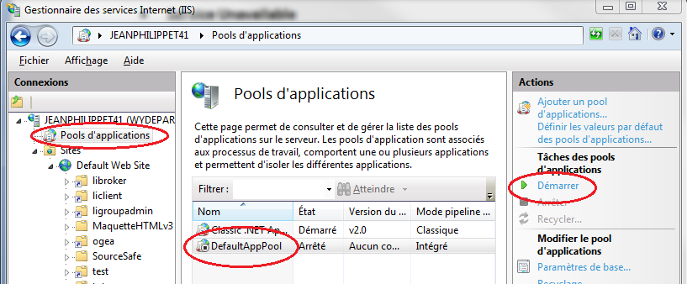
* **Error in browser : No data received, cannot find address …  
  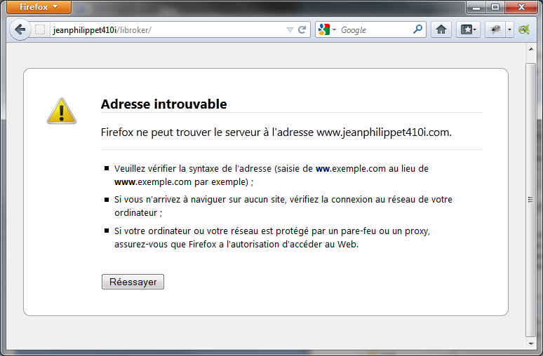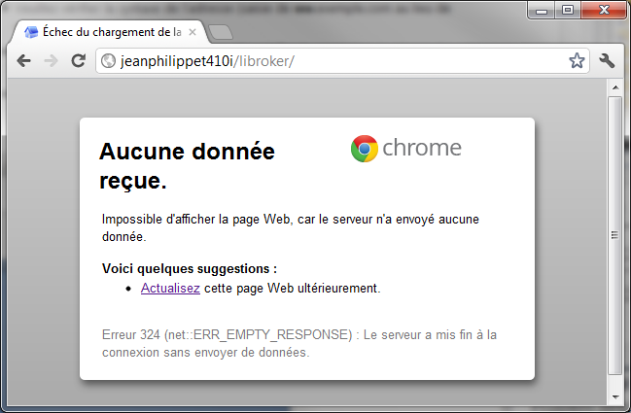**
  + Problem description  
    all wPortal class has been renamed in 4.6, so the reference about wPortal Server in WySeMan should match the wPortal class name.
  + How to solve the problem  
    Verify in (WYDE-ROOT)\WSMServer\WNETCONF.ini the parameterSERVERCLASS 🡺 it should be : SERVERCLASS:GSP=aPCB_GSPServer  
    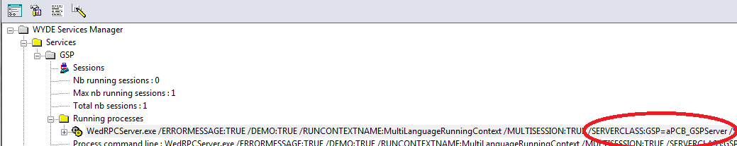
* **No login is displayed in test dialog box.**
  + Problem description  
    If your database is empty, or you have not configured the good database, this problem happens.
  + How to solve the problem  
    Verify that you have configured the correct database in C:\WyseMan\WNETCONF.ini file on AppServer with the parameter /RUNCONTEXTNAME. If you are confident on this configuration, maybe you should fill database with the test case builder (launching Wynsure for example).
* **Where can I create some login?**
  + Problem description  
    You first have to create the login in Wynsure to be able to connect.
  + How to solve the problem  
    To create a login for a person: Modify a person 🡺 Folder “Customer” 🡺 “Edit login” 🡺 set the appropriate Organization Unit, Distribution Unit, (name is the login), set “WEB” profile then validate  
    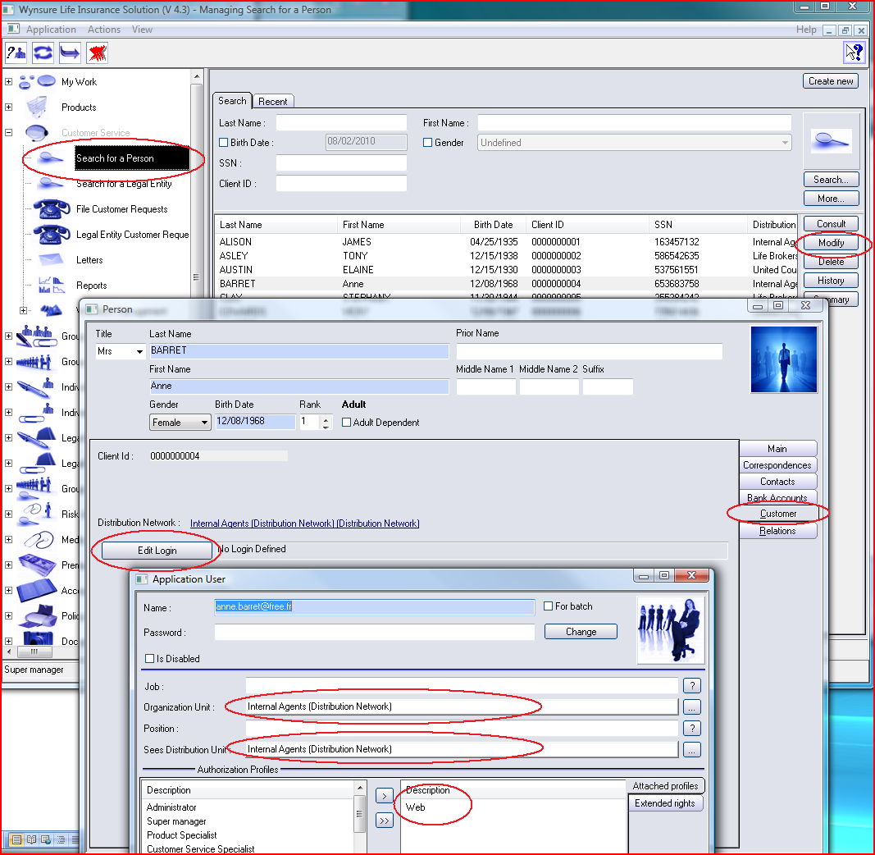  
    You can do the same thing for a broker.

1. Install wPortal with SQL Server or Oracle

Only one class in wPortal is persistent: aPT_SessionInfo

This class doesn’t need to be versioned.

1. End of document